BMI CALCULATOR APPLICATION

A MINI-PROJECT REPORT
Submitted by

HARINI G 190701266

in partial fulfillment of the award of the degree of

BACHELOR OF ENGINEERING
IN
COMPUTER SCIENCE ENGINEERING




RAJALAKSHMI ENGINEERING COLLEGE, ANNA UNIVERSITY: CHENNAI 600 025

JUNE 2022

BONAFIDE CERTIFICATE

Certified that this project “BMI CALCULATOR APPLICATION” is the bonafide work of , “HARINI G (190701266)” who carried out the project work under my supervision.

SIGNATURE
MS. S. Ponmani

ASSISTANT PROFESSOR(SG)

Dept. of Computer Science and Engg, Rajalakshmi Engineering College, Chennai - 602105

Submitted to Project Viva-Voce Examination held on

INTERNAL EXAMINER EXTERNAL EXAMINER

ABSTRACT

The body mass index (BMI) is the metric currently in use for outlining anthropometric height and weight characteristics in adults and for classifying them into groups. The common interpretation is that it represents an index of an individual’s fatness. It is also widely used as a risk factor for the event of or the prevalence of several health issues. The Body Mass Index (BMI) Calculator App is a software programme that eliminates the need for more manual hours to calculate and locate the BMI for a specific person with a single click. This application incorporates both American and Indian standards. This app provides all of the information in both standards that is not available in any other app. The major goal is to keep one's health in good shape. The BMI App provides us with all of the necessary information, such as health recommendations and advice on what to eat and what to avoid.

ACKNOWLEDGEMENT

First, we thank the almighty god for the successful completion of the project. Our sincere thanks to our Chairman Mr. S. Meganathan, B.E., F.I.E., for his sincere endeavor in educating us in his premier institution. We would like to express our deep gratitude to our beloved Chairperson Dr. Thangam Meganathan, Ph.D., for her enthusiastic motivation which inspired us a lot in completing this project and Vice Chairman Mr. Abhay Shankar Meganathan, B.E., M.S., for providing us with the requisite infrastructure. We also express our sincere gratitude to our college Principal, Dr. S.N. Murugesan M.E., PhD., and Dr. Revathy M.E., Ph.D., Head of the Department of Computer Science and Engineering and our project guide Ms. S. Ponmani for her encouragement and guiding us throughout the project and to our parents, friends, all faculty members and supporting staffs for their direct and indirect involvement in successful completion of the project for their encouragement and support.

ADHARSH A AKHASH S

TABLE OF CONTENTS

CHAPTER | TITLE | PAGE NO
NO
1 | INTRODUCTION | 1
1.1  1.2  1.3 | INTRODUCTION  LITERATURE SURVEY  EXISTING SYSTEM | 1  2  3
1.4 | PROPOSED SYSTEM | 4
2 | SYSTEM ARCHITECTURE | 5
3 | PROJECT DESCRIPTION | 7
3.1 | USECASE DIAGRAM | 7
3.2 | FLOW DIAGRAM | 8
3.3 | REQUIREMENTS | 9
3.3.1 | HARDWARE REQUIREMENTS | 9
3.3.2 | SOFTWARE REQUIREMENTS | 9
3.4 | OUTPUT | 10
4 | CONCLUSION AND FUTURE WORK | 11
4.1 | CONCLUSION | 11
4.2 | FUTURE ENHANCEMENT | 11
 | APPENDICES | 12
 | REFERENCE | 16

CHAPTER 1 INTRODUCTION

  - INTRODUCTION

The overweight (Body mass index [BMI] for age and sex from the 85th percentile to the 95th percentile) and obesity (BMI for age and sex greater than or adequate to the 95th percentile) are related to the present and future health of youth also as their academic success. Youth classified as overweight or obese are more likely to be diagnosed with prediabetes (impaired fasting glucose or impaired glucose tolerance) and have more cardio metabolic risk factors than normal weight youth. Various methods for assessing body composition, used for children and adolescents in research settings (for example, hydrodensitometry, plethysmography of air displacement, isotope dilution, two-energy X-ray absorptiometry). The use of these methods in a community setting is limited. As a result, measuring height and weight to calculate body mass index is recommended for overweight/obese people in screening for the younger generation. (BMI? body weight (kg) / height (square meters). Android is used in over 190 countries and powers hundreds of millions of mobile devices. It has the largest installed base of any mobile platform and is rapidly expanding—every day, a million new Android users turn on their devices for the first time and begin searching for apps, games, and other digital content. Android provides you with a world-class platform for developing apps and games for Android users around the world, as well as an open marketplace for quickly distributing them. This Android application has handy tools for arithmetic, scientific, and converting calculations. It would be particularly useful for students, as they account for the bulk of smartphone users in today's world, and they require tools to help them with the lengthy calculations they must perform in their studies.

LITERATURE SURVEY

Body Mass Index (BMI) is a person’s weight in kilograms (or pounds) divided by the square of height in meters (or feet). A high BMI can indicate high body fatness. BMI screens for weight categories that may lead to health problems, but it does not diagnose the body fatness or health of an individual.
Using the formula, the BMI calculator uses smart technology to help people decide if they are underweight, overweight, obese or in the normal category.
According to the World Health Organization, the body weight values (kg/m ²) for adults (men and women above 18 years of age) are:
- Underweight - less than 18.5
- Normal- 18.5 - 25
- Overweight - 25 - 30
- Obese - above 30
Being underweight or overweight may be an indicator of various underlying health problems such as high BP, diabetes, heart disease, stroke, arthritis, breathing problems in overweight individuals, and malnutrition, vitamin deficiencies, anaemia, osteoporosis, poor immune system in underweight people.
The BMI calculator can come in handy to help people aim for fitness targets.
However, having said that, the tool isn't 100 per cent accurate, and has previously attracted some critcism in the past. The calculation fails to include waist measurement, which has become a deciding factor in many obesity-related cases.
In order to ensure complete health and fitness, people must first focus on a regular workout plan, balanced diet and hydration and proper sleep pattern.

EXISTING SYSTEM

The existing system is very time-consuming and complex to calculate. Calculators are small electrical devices that can perform basic and advanced calculations in a fraction of a second. The concept of a unit is created using a Franchise, which was first used in 2000 BC; after a number of inventions and mechanical counting machines were developed. The scientific calculators were created to assist in performing scientific calculations. However, in the 21th century, when people started using with personal computers, tablets, mobile phones and other electronic devices, so what to wear such as calculators?

PROPOSED SYSTEM

The BMI Calculator Application is a software programme that eliminates the need for more manual hours to calculate and locate the BMI for a specific person with a single click. This application incorporates both American and Indian standards. This application provides all of the information in both standards that is not available in any other application. BMI is calculated the same way for both adults and children.
Formula: weight (kg) / [height (m)]²

With the metric system, the formula for BMI is weight in kilograms divided by height in meters squared. Because height is commonly measured in centimetres, divide height in centimetres by 100 to obtain height in meters.
Example:

Weight = 68 kg, Height = 165 cm (1.65 m) Calculation: 68 ÷ (1.65)2 = 24.98

BMI table for adults: The World Health Organization's (WHO) recommended body weight based on BMI values for adults. It is used for both men and women, age 18 or older.
BMI table for children and teens, age 2-20: The Centres for Disease Control and Prevention (CDC) recommends BMI categorization for children and teens between age 2 and 20.

CHAPTER 2 SYSTEM ARCHITECTURE

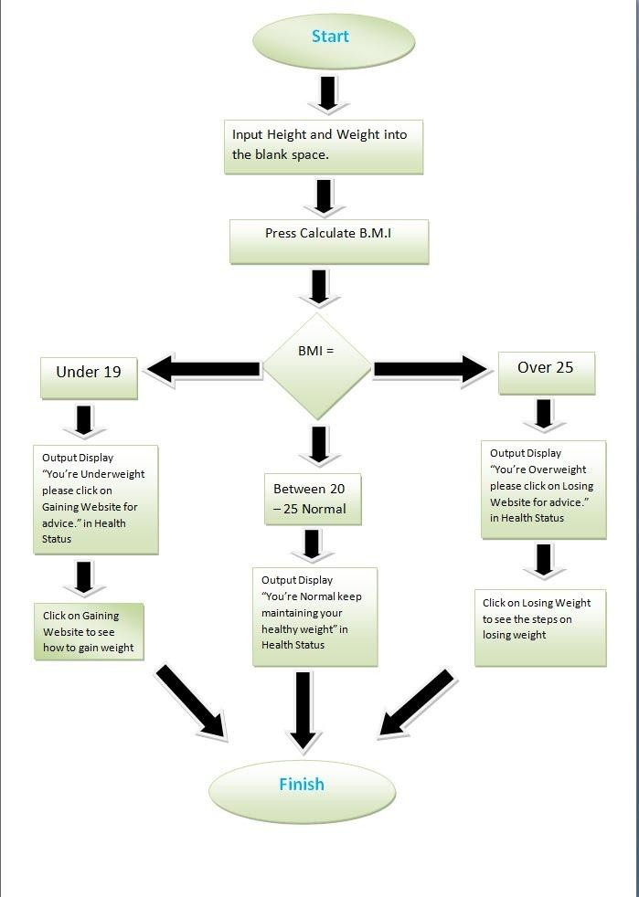

System architecture is the conceptual model that defines the structure, behavior, and views of a system. An architecture description is a formal description and representation of a system, organized in a way that supports reasoning about the structures and behaviors of the system. A system architecture can comprise system components, the expanded systems developed, that will work together to implement the overall system.

The system architecture shows the overall functionalities of the application the flow is as follows, entering the required height , weight and age.

CHAPTER 3 PROJECT DESCRIPTION

USE CASE DIAGRAM

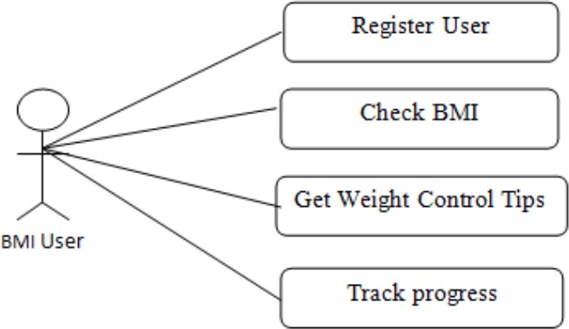

The use case diagram portrays the entities involved in the given application as stated in Figure 2. The user of the app and the device are the sole entities and the functionalities selected by the user are implemented using the device entity. The functionalities involved in the given application are calculating Body Mass Index, Input measurements etc.

FLOW DIAGRAM

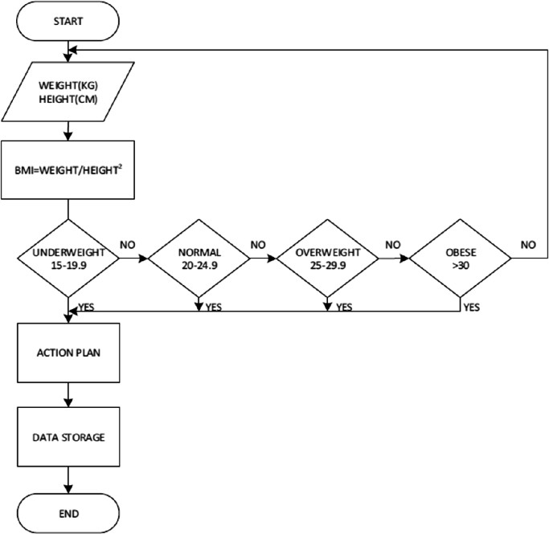

The flow diagram shows the flow of the application and the working of the entire application. Since the user is the only external entity interacting with the application the flow is direct and with respect to the user only. The user when interacting with the app will have to enter the height, weight and age. The user will get the BMI as output . The user can recalculate his/her height by clicking on the re-calculate button.

REQUIREMENTS
    - HARDWARE REQUIREMENTS

      - Laptop
      - Android Phone

    - SOFTWARE REQUIREMENTS

      - Intel i3
      - Android Studio
      - Android OS

OUTPUT
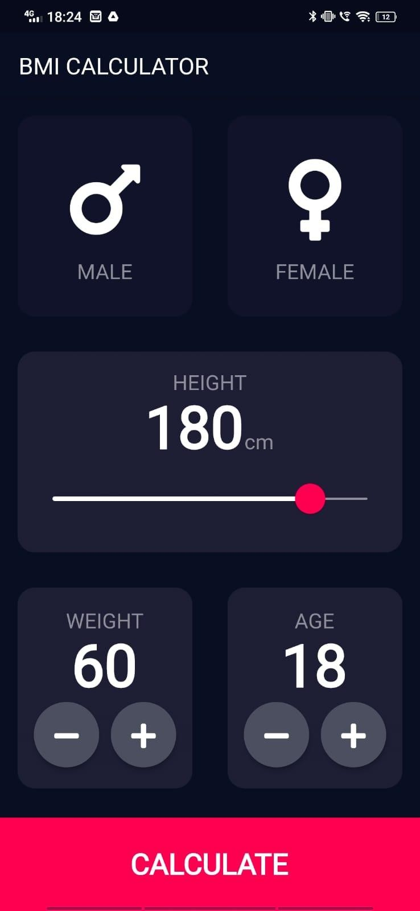

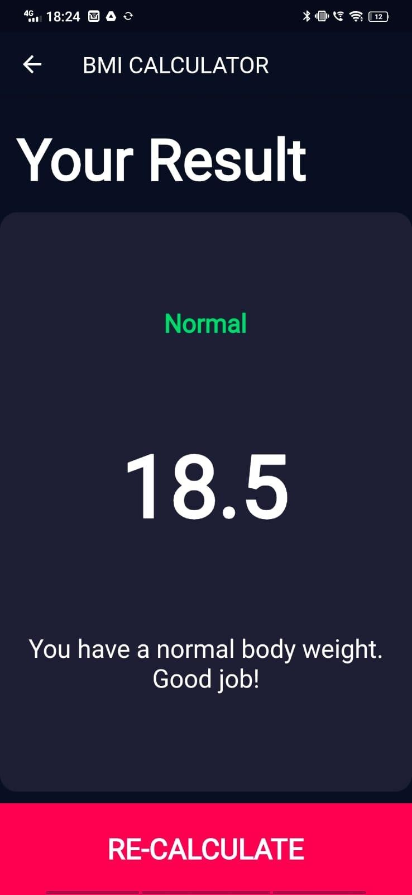

CHAPTER 4 CONCLUSION AND FUTURE WORK

4.1 CONCLUSION

The package was created in such a way that future changes are simple to implement. The following conclusions can be drawn from the project's progress. The efficiency of the entire system is improved by automating it. It has a user-friendly graphical user interface that outperforms the current system. It grants authorised users appropriate access based on their permissions. It effectively solves the problem of time complexity. It has never been easier to keep information up to date. The most notable features are system security, data security, and dependability. If necessary, the System has enough flexibility to be modified in the future.

4.2 FUTURE WORK

BMI, the current standard for determining if you are at a healthy weight, may be on its way out.
According to researchers, a more accurate way to measure whether you are at risk for obesity-related diseases is your waist-to-height ratio.
Your BMI, which stands for body mass index, calculates a number based on your height and weight that shows if you are a normal weight, overweight, obese or underweight. However, it doesn’t take muscle mass or the distribution of fat around the body into consideration.
A review of 31 studies that included more than 300,000 men and women found that waist-to-height ratio was better than BMI at predicting certain health risks associated with obesity, including high blood pressure, diabetes, heart attacks and strokes.

.

APPENDIX I

main.dart
import 'package:flutter/material.dart'; import 'inputpage1.dart';
void main() => runApp(BMICalculator());

class BMICalculator extends StatelessWidget { @override
Widget build(BuildContext context) { return MaterialApp(
theme: ThemeData.dark().copyWith( primaryColor: Color(0xFF0A0E21),
scaffoldBackgroundColor: Color(0xFF0A0E21)
),

home: InputPage(),
);
}
}

CalculatorBrain.dart import 'dart:math'; class CalculatorBrain{
CalculatorBrain(this.height, this.weight);

final int height; final int weight; double _bmi;

String calculate(){
_bmi = weight / pow(height/100, 2); return _bmi.toStringAsFixed(1);
}

String getResult(){
if(_bmi >= 25){ return 'OverWeight';
} else if(_bmi > 18.5){ return 'Normal';
} else{
return 'Underweight';
}
}

String getAdvice(){
if(_bmi >= 25){
return 'You have a higher than normal body weight. Try to exercise more!';
} else if(_bmi > 18.5){
return 'You have a normal body weight. Good job!';
} else{
return 'You have a lower than normal body weight. You can eat a bit more!';
}
}
}

results_page.dart
import 'package:bmi_calculator/bottom_button.dart'; import 'package:bmi_calculator/consts.dart';

import 'package:bmi_calculator/reusable_card.dart'; import 'package:flutter/material.dart';

class ResultsPage extends StatelessWidget {

final String bmitext,bmivalue,advice; ResultsPage(this.bmivalue,this.bmitext,this.advice);

@override
Widget build(BuildContext context) { return Scaffold(
appBar: AppBar(
title: Text('BMI CALCULATOR'),
),
body: Column(
crossAxisAlignment: CrossAxisAlignment.stretch, children: [
Expanded( child: Container(
padding: EdgeInsets.all(15.0), alignment: Alignment.bottomLeft, child: Text(
"Your Result",
style: kTitleTextStyle,
),
),
),
Expanded(

flex: 5,
child: Reusablecard( colour: kactiveCardColor, cardchild: Column(
crossAxisAlignment: CrossAxisAlignment.center,

mainAxisAlignment: MainAxisAlignment.spaceEvenly, children: [
Text( bmitext,
style: kResultTextStyle,
),
Text( bmivalue,
style: kBMIvalueStyle,
),
Text( advice,
textAlign: TextAlign.center, style: kBodyTextStyle,
),
],
),
),
),
BottomButton("RE-CALCULATE", () { Navigator.pop(context);
})
],
),
);
}
}

REFERENCES

- https://www.cdc.gov/healthyweight/assessing/bmi/adult_bmi/index.html

- Kuczmarski RJ, Flegal KM, Campbell SM, Johnson CL. Increase prevalence of overweight among US adults. The National Health and Nutrition Examination Surveys, 1960 to 1991. JAMA. 1994; 272(3):205Y211

- Barlow, S. E., Bobra, S. R., Elliott, M. B., Brownson, R. C., & Haire-Joshu, D. (2007). Recognition of childhood overweight during health supervision visits: Does BMI help pediatricians? Obesity (Silver Spring), 15, 225–232. doi:10.1038/oby.2007. 535

- Brener, N. D., Eaton, D. K., Lowry, R., & McManus, T. (2004). The association between weight perception and BMI among high school students. Obesity Research, 12, 1866–1874. doi: 10.1038/oby.2004.232

- https://www.calculator.net/bmi

